

Operations Management and Service Excellence

1

Table of Contents

Introduction 3

Introduction and overview About Kaffeine 4

Location of the Business 6

Capacity of the café Error! Bookmark not defined.

Type of customers it serves Error! Bookmark not defined.

Layout Error! Bookmark not defined.

Services Offered Error! Bookmark not defined.

Analysis of how operation management process support the coffee shop 7

Market Segmentation Error! Bookmark not defined.

Early Supply Chain Error! Bookmark not defined.

Finance: Error! Bookmark not defined.

Quality Control Error! Bookmark not defined.

Store Location and layout evaluation Error! Bookmark not defined.

Critical Discussion regarding how the 5 performance objectives applied in Kaffeine coffee shop

13

Quality 13

Speed: 14

Dependability 15

Flexibility 16

Cost 16

Recommendation for Improvement 17

Supply chain for Kaffeine coffee shop 17

Identification of the improvement that are recommended to the operation and justification with

rationale 19

2

Conclusion 20

References 21

Introduction

Maintaining effectiveness within the organization is an important aspect to consider when it comes to generating and gathering proper actions that can fulfil the objectives for the organization. This report will undertake several aspects under consideration highlighting the necessary attributes and implication relating to the operations management and their ability to stimulate and perform effectively so that these can ensure a quality impact on the growth of the organization. Several proposition and implication relating to the operations management and service excellence will be carried out highlighting the context of Kaffeine.

3

Introduction

This report will address the key idea and application about the operations management and their applications based on the given framework. The consideration for the tasks will be carried out taking the key factors and frameworks of Kaffeine which is one of the popular brands in UK. Determining the best possible approach the key areas and implications will be addressed and utilized within it so that the key consideration and implication regarding this can be utilized and applied for the further possible assessment and evaluation.

Overview about Kaffeine

Kaffeine is a small but popular coffee shop owned and operated under Aussie/Kiwi owned coffee shop with deli style breakfast’s sandwiches and salads. To operate with effective consideration for the consumers they offer amazing cakes, great coffee (Greasley, 2008).

When it comes to overview of the performance of the Kaffeine this is one of the popular coffee shop in the city having the small outreach but loyal consumers for its products and services (Slack, Brandon-Jones and Johnston, 2017). To be able to assure that these are being carried out in an effective manner more and more focus has been carried out highlighting the proper understanding about the consumers and also determining the best possible response for the operational growth and implication (Greasley, 2008).

4



Overview of Kaffeine:

Name | Kaffeine
Opening timing | Wednesday to Sunday:
 | 12pm-2pm
 | Monday:
 | 5.00pm-11.00pm
Services: | Flat white, cappuccino or latte etc. Beverages and so on
Staff | 3 manager, 4 chefs, 5 customer server 2 driver
Industry | Dining, Home delivery, takeaway
Customer Type | professionals and also young adults
Capacity | 30 seats where 5 people per bench
Table 1: Overview of Kaffeine

5

Location and Layout of the Business

It is located in 66 Great Titchfield St, Fitzrovia in London. Therefore, for the people around it several responsive result can be recovered and applied for the further set of action and reflective implication for the further business and reach for the consumers (Brennan, 2011).
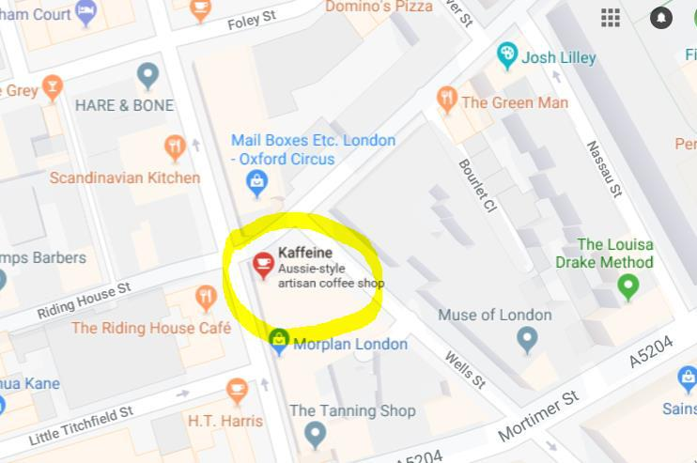

Location of Kaffeine

One of the major consideration that has been put through in order to determine and develop the best possible support for the people include the outdoor seating, basement lounge and different types of background that promotes quitter atmosphere (Schiuma, 2011). These shows a competitive understanding about the customers and their requirement in an effective manner. Informative offerings are offered in the case of each service and their respective implication for the customers (Schaltegger and Wagner, 2006). In that case the overall strategy of its operation is developed based on few factors like inventory management, layout plan, process orientation, quality offerings and competitive features.

6

Shop Layout
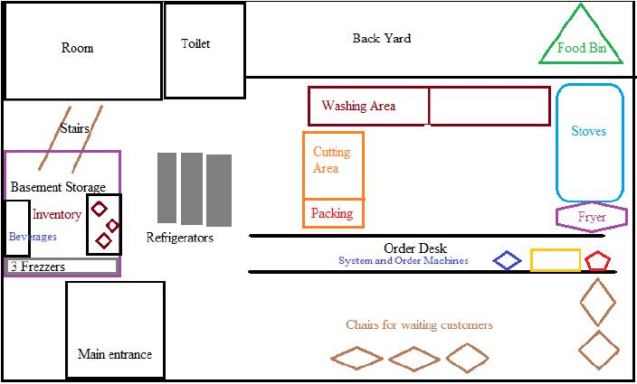

Figure: Shop Layout

Competitors:

Several competitors have been identified and these include: Monmouth coffee company Flat white, Fix Coffee, Wilton way café etc.

Analysis of how operation management process support the coffee shop

Operations Management of Kaffeine means the management areas that is concerned with the planning and control of the production process in a systematic manner and these will help to gain competency over practical scenario and implication. The production of goods and services are being associated with it. The operations include:

7


Order Taking

Food
Preparation

Waste
Management

Stock control

Key process of Kaffeine:

These can be categorized in two major part and these are given below:

- Collection process and

- Delivery process

The collection process is one of the key processes of the organization and these can be reflected as a sequential approach for the organization. However, these are being addressed below:
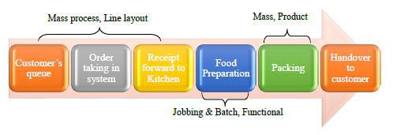

Figure: Collection process of Kaffeine

8

On the other hand the basic approaches of delivery process is attached with the necessary attributes and these are given below:
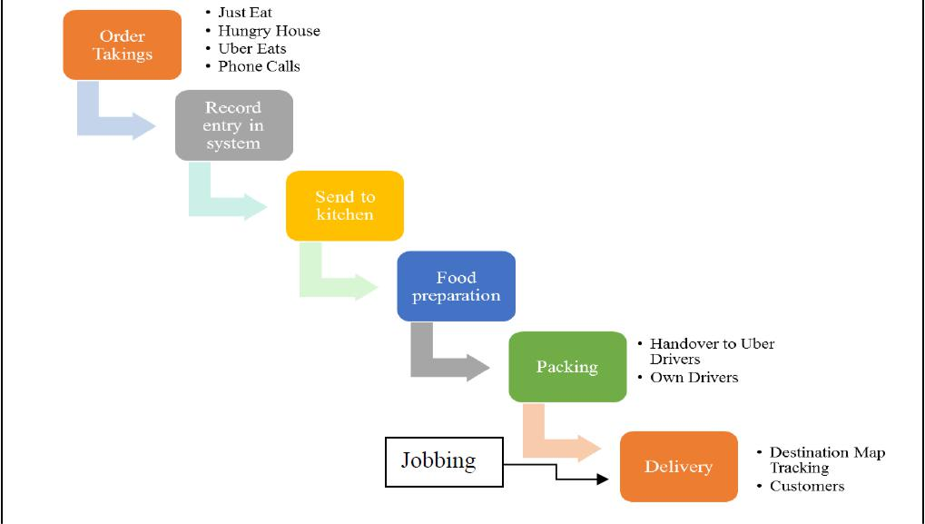

Figure: Delivery processes of Kaffeine

Internal process of Kaffeine: the idea and application for the internal processes are associated with the key objectives that highlights the necessary attributes of operations management and these are being addressed below:

Planning and control Activities

Taking the demand and supply under consideration this has been addressed as one of the key processes and practices for the organization. these are addressed below:

9

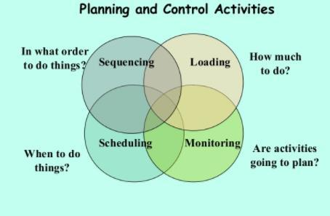

Figure: Planning and control activates

These are being carried out in an effective manner and these are being given below:

 | Scheduling | Timetable of staff:
 |  | Off day of chefs are sequentially that is chef 1 gets off day in Monday,
 |  | then chef 2 gets in Wednesday
 |  | Staff timing weekend is 12 pm-11pm
 |  | Meat: weekly
 |  | Cutting vegetables: Everyday
 |  | Cookies & Beverage: Everyday
 |  | Grocery: Fortnightly
 | Loading | 2 drivers are appointed for 25 deliveries per day
 |  | 2 computers for online orders and processing
 | Sequencing | Manager takes order and forward to chefs

10

 |  |  |  | Then manager take the prepared food and provide to the caterers or
 |  |  |  | customers directly
 | Monitoring | and |  | Cleaning daily
 | control |  |  | Changing oil and maintenance

Waste Management:

Managing wastes is one of the major concern for the businesses and these are needed to be taken under serious consideration in order to maximize and generate a higher output and result for the quality consideration. All the wastes including the bottles, cans and cardboard boxes are being recycled as these are being produced and used in a way that can be reused for the future and practical process and application.

Why waste Management is important:

Waste management is very important due to the close relationship and implication for the operations that may decide the output for the operations. These are being addressed and utilized in a competitive manner having the necessary standards and implication to maintain safety and output for the operations. These efforts are being appreciated by the customers due to the consideration for the environment and their implication for the future response for the environment. These have also being considered and utilized in a way that helped to point out the basic and standard platform and place for the organizational and operational facilitation. In terms of waste management these are being carried out 3 times a week. The cost of waste management is minimal as these are done by owner itself. Then the manager is responsible in this context as the waste management bears many importance on the actions.

4 V’s of Operations Management:

Taking the factors of volume, variety, variation in demand and visibility these can be considered and utilized for the practices of understanding operations management in Kaffeine. These seem to be effective when it comes to applying these in the workplace and practical operations.
11

Dimension of Volume: Volume of products and services are offered as per the demand for the organization and these are being done in order to demonstrate a quality consideration for the services that the consumers wanted and the way these are being provided to them effectively.
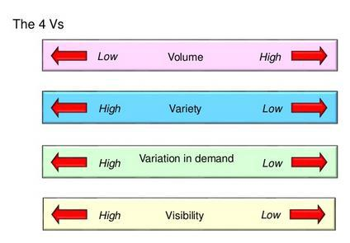

Figure: 4 V’s of operations of management

Dimension of Variety Then Variety of products are being taken under consideration. Kaffeine uses different ways of products while service and these include range of coffees for the customers or light shakes that allowed the consumers have better option for their respective demand.

Dimension of Variation: Variation demand is another approach where these are being met with effective focus on the organization. The basic and practical consideration for the operations can be pointed out and placed highlighting the availability for the services that are being offered to the consumers. Kaffeine allows the consumers to have better support in the process of making their choice that allowed to maintain a good communication with the products and services.

Dimension of Visibility: Visibility is another approach that are being seen in an effective manner for Kaffeine. they introduces and analyzed the way their location and decoration can meet the demand for the public and these are being addressed in an effective manner.

12

Critical Discussion regarding how the 5 performance objectives applied in Kaffeine coffee shop

The performance objectives are developed and derived focusing on the necessary attributes that not only allows to have the proper focus on the operation but also stimulate the way these are being offered and applied by the organization (Kelemen, 2003). to be able to point out and determine the best possible remark several factors are being considered and utilized for the operation where these factors are being considered and utilized for the further set of action and implication. These will be taken on the basis of the survey that are being carried out for the organization and the survey question is attached in appendix 1.
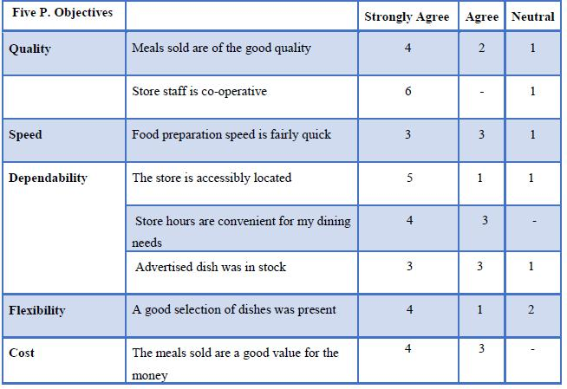

Figure: Questionnaire for the customers

Quality

The quality of the coffee shop is being derived and developed focusing on the standards and also respective influence of global excellence measurement that can ensure a better satisfaction from 13

the customers’ perspectives (Schaltegger and Wagner, 2006). The service and product quality can be derived and developed taking different practices under consideration where the market condition is being promoted and utilized having the necessary highlight on the utilization of the customer attraction and maintenance of the loyalty in an effective manner.

These include:

- Food hygiene

- Good taste

- Tidiness of shop Cooperative and friendly staff

Customer loyalty is being ensured and these are being utilized taking the consideration for the operational and practical output and impact on the development of the consumers need (Schiuma, 2011). Current firm that is Kaffeine enjoys this in an effective manner due to its strong commitment to the quality and their respective implication that can be achieved and applied through the practice of the organization. Kaffeine follows specific quality standards from collecting their raw materials to the serving the necessary placement for the operation. When it comes to the evaluation from the actual to estimated quality consideration these are more than par for the performance in terms of quality and adaption.

Speed:

Taking the consideration for the Sped factors these are largely associated with the necessary focus on the volume and areas of operation that can be considered and applied (Jolly, 2003). The practical focus on the operation helps to reduce the operational cost and also determining the delivery of the products and raw materials. These are being derived and developed highlighting the necessary focus on the operation.

- Sort Queue

- Prepare food quickly

- Food delivery on time

14

Quality service and their response time are relevant in terms of ensuring proper support for the services and these are being carried out as one of the important perspective that needs to be driven for the further implication (McNulty, 2004). Early maintenance and quality delivery is considered while taking factors of operations under consideration. Kaffeine gains the reputation for service that are speedy enough to get the customers attention and these are being seen within the review of the customers. Almost 70% of the consumers have reviewed that they have higher response rate for the services.

Dependability

Taking this under consideration organization tries to develop a commitment towards the customers and also these are being maintained with reflection to the necessary attributes for the performance in the long run. The placement for the order is being judged by the customers and in order to gain a higher benefit out of it these need to be ensured and applied for the better response and implication for the further achievement and output (Connell and Teo, 2010).

- Consistency in taste

- Open during all timings

- Accessible location

- Advertise dishes in stock

- Easy payment methods

when it comes to survey that are being carried out for the consumer perception it showed that 85% of the consumers get the better representation for the dependable coffee brand. Kaffeine has performed effectively well in this category.

15

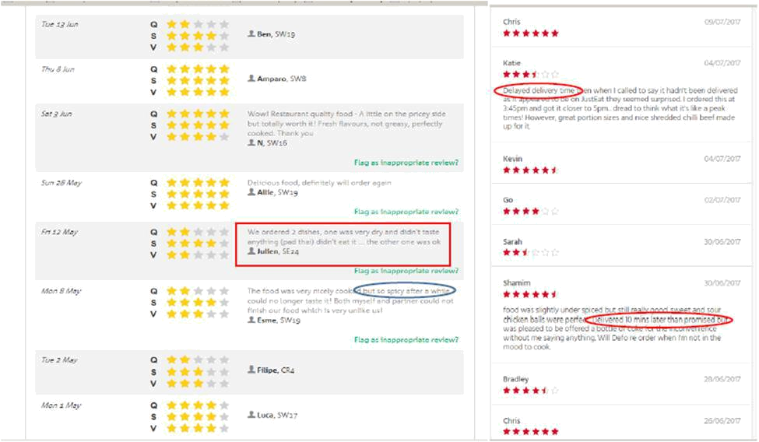

Figure: Understanding the review of the customers.

Flexibility

The ability to adapt change in the operational and operational process known as flexibility for the organization. These are needed to be applied and utilized in a way that not only allows to have the necessary influence on the customer loyalty but also ability to sustain in the market. However, to be able to point out the necessary standards and implication for the operation these can be considered and utilized having the best possible response and effectiveness in the way of making a quality implication for the management process and also dependability that can be maintained throughout the operations (Chang, 2010). Kaffeine kept the option for the flexibility that not only demonstrated a higher result but also pointed out the best possible remark for the operation in an effective manner. Different sets of perception and reviewed were carried out and 75% consumers find them flexible to meet the demand for the consumers.

Cost

One of the major areas that are being concerned with the factor include the cost (Evardsson and Gustafsson, 2005). This is being addressed in order to assure competitiveness for the operation

and these can be derived and developed highlighting the necessary actions to minimize the cost 16

having efficiency in the operation and their respective implication for the further adaption of the method that can help to gain competitive position in the market. Kaffeine undertakes the areas and issues of cost in an effective manner focusing on the necessary attributes based on the necessary implication where they considers the condition of the consumers in an effective manner.

Recommendation for Improvement

When it comes to the consideration for the improvement it is necessary to address the proper focus on the necessary areas where the initial actions need to be improved in an effective manner. These will help to understand the needs and apply in a way that can allow to utilize the best possible implication for the organizational and operational output and evaluation. It needs to adapt technical support that can help to outreach more actions and services for the customers (De Waal, 2013). Improvement in the housekeeping needs to be addressed for the better reflection of its quality consideration.

Supply chain for Kaffeine coffee shop

To operate in an effective manner, it is necessary to introduce an effective supply chain for the operation and these are needed and utilized in a way that can help to gain a better implication for the operation (Porter and Teich, 2011). There are different actions that are being placed and utilized for the necessary attributes of the organization. Adaption of effective supply chain model can help to benefit for the organization. According to the need of the organization outsourcing needs to be carried out highlighting the necessary standards and implication for the operation (Cassia, Fattore and Paleari, 2006). These are needed to be implemented in a sequential manner and these are given below:

17

Receiving

coffee

beans

Failed /

Discard

Storage

Final

Testing

Packaging

Shifter


Blending

Palletizing

Assortment  Roasting

Quality

Cooling
Testing

Finished |  | Failed/
goods |  | Discard

Order

Fulfillment

Figure: Supply chain of Coffee shop, source: Self Made

Supply chain means the flow of goods and services involves the movement and store of raw materials and of work in process inventory and of finished goods from point of origin to point of consumption. These can be derived based on the specific suppliers for the business organization. Kaffeine undertakes the supply chain with more serious focus so that these can help to gain competency in the way of making an effective understanding and adaption for the operational practices and evaluations in the long run. They have multiple suppliers when it comes to collecting coffee beans for the operations. These are being carried out to the respective collectors for the organization. The key suppliers are given below:

- Regency Coffee who supply the fair trade coffee beans to the business

- Jurang Fair trade also supply coffee beans

- Kitchen Garden is another supplier who is offering different additional products needed for

the products of Kaffeine

18

There are several other suppliers who are the key part of the supply chain but the basic suppliers for the organization are addressed above. Depending on the needs the Coffee making machine, Furniture and other ingredients are also part of the supply chain and most of the case these are custom made for the Kaffeine and these are the key supplier for the organization as well.

The solution for making an effective approach and implication for the coffee shop can be made and utilized highlighting the best possible remark and implication for the further action that is being carried out for the performance based action doing and also acting upon the task for the continuous development and implication (Gaither and Frazier, 2002). Kaffeine uses this model in order to gain competency and also attain better support in its way of making a better impact on the operations.

Identification of the improvement that are recommended to the operation and justification with rationale

There are several areas that can be considered as the improvement requirement for the further development of the tasks and implication (Yu, 2016). These can be considered and utilized taking the necessary aspects under consideration. These are being given below:

- Ensuring High products and performance in the daily operations: to stand out from the crowd and making its operation more competitive it needs to introduce more and more products along with service excellence in the way of making an effective consideration for the operation. These will help to generate and point out the necessary implication for the organizational attribute and evaluation for the operation (Kumar and Suresh, 2009). Kaffeine gets the better support if it offers high standard products to the consumers

- Smaller Supply chain: this will help to build more fast and effective implication in the supply chain and adaption of the services in a more efficient manner. These are associated with the operations management and thus a quality and effective output can be applied in the organizations.

- Quality waste management: to be able to generate and highlight the action in an effective manner it is necessary to expand its operation in an effective manner (Jones and Robinson,

19

2012). Market service development and implication can be enriched and practiced by different set of implication and evaluation for the organization. as waste management is an important and effective part of the operations.

- Product and service improvement: to make proper enhancement in the operation it is necessary to have diversified product and their respective implication for the necessary development in the operation. These can be carried out highlighting the necessary set of action and also generating the needed implication for the flexibility and proper action for the organization (Hill and Hill, 2012). Different customer group including students, families and professionals are being addressed utilizing the necessary integration in the operation which will help Kaffeine to engage more in the operational development and application for the services. And respective of the operation these are needed to be improved.

- Assuring service Excellence: getting more customers will not indicate successful service and these are needed to be implement with regards to the better enhancement in the operation (Greasley, 2008). These can be utilized in a way that not only helps to point out the necessary engagement but also assures proper facilitation in the way of having service excellence in the operational level.

These are the key recommendation that the organization can apply in the areas of operation and these will help to achieve the objectives in an effective manner where the basic output and implication is being derived focusing on the relative implication on the coffee business and operations management (Brennan, 2011).

Conclusion

This report critically addresses the necessary attributes and implication for the operations management and different types of service excellence where these allow to create major impact on the way of making an effective contribution in the performance and implication. Multiple set of evaluation and their analysis has been made focusing on the necessary attributes of operations management and their ability to stimulate the performance for the organization. To be able to point out the necessary attributes for the operation different operational facilitation and their respective

20

integration for the further development has been made focusing on the recommendation that are being derived through the analysis and application for the organizational output and evaluation.

References

Bonanno, A. and Cavalcanti, J. (2011). Globalization and the time-space reorganization.
Bingley: Emerald.

Brennan, L. (2011). Operations management. New York: McGraw-Hill.

Cassia, L., Fattore, M. and Paleari, S. (2006). Entrepreneurial strategy. Cheltenham: Edward Elgar.

Chang, C. (2010). Service systems management and engineering. Hoboken, N.J.: John Wiley & Sons.

Connell, J. and Teo, S. (2010). Strategic HRM. Prahran, Vic: Tilde University Press.

De Waal, H. (2013). Designing and implementing successful dementia care services. Chichester, West Sussex: John Wiley & Sons.

Evardsson, B. and Gustafsson, A. (2005). QUIS 9 symposium. Bradford, England: Emerald Group Pub.

Gaither, N. and Frazier, G. (2002). Operations management. Cincinnati, Ohio: South-Western/Thomson Learning.

Greasley, A. (2008). Operations management. Los Angeles: SAGE.

Hill, A. and Hill, T. (2012). Operations management. Basingstoke: Palgrave Macmillan.

Jolly, A. (2003). Managing business risk. London: Kogan Page.

Jones, P. and Robinson, P. (2012). Operations management. Oxford: Oxford University Press.

Kelemen, M. (2003). Managing Quality: Managerial and Critical Perspectives. Sage Publications.

Kumar, S. and Suresh, N. (2009). Operations management. New Delhi: New Age International.

McNulty, G. (2004). Proceedings of the 5th International Conference on Quality, Reliability, and Maintenance. Bury St. Edmunds, UK: Professional Engineering.

Mead, J. and Gruneberg, S. (n.d.). Programme procurement in construction.

21

Onuoha, A. (2008). When communities confront corporations. London, UK: Adonis & Abbey Publishers.

Porter, R. and Teich, M. (2011). Drugs and Narcotics in History. Cambridge, GBR: Cambridge University Press.

Schaltegger, S. and Wagner, M. (2006). Managing the business case for sustainability. Sheffield, UK: Greenleaf.

Schiuma, G. (2011). The value of arts for business. Cambridge, UK: Cambridge University Press.

Slack, N., Brandon-Jones, A. and Johnston, R. (2017). Operations management. Cape Town:
Pearson.

Yu, L. (2016). The international hospitality business. New York: Routledge.

Appendix

Appendix 2:


Café capacity

22



Café layout
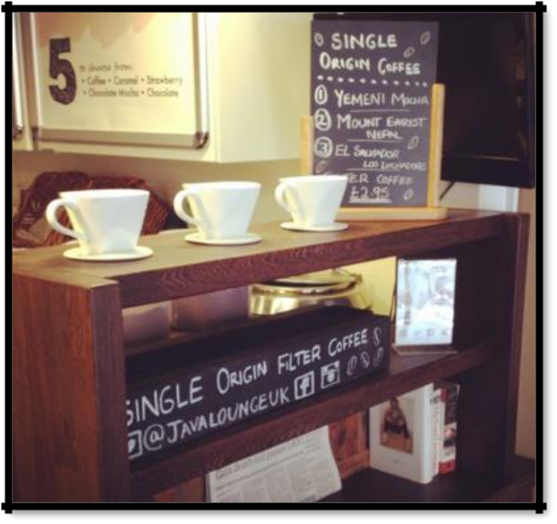

Café ambience

23

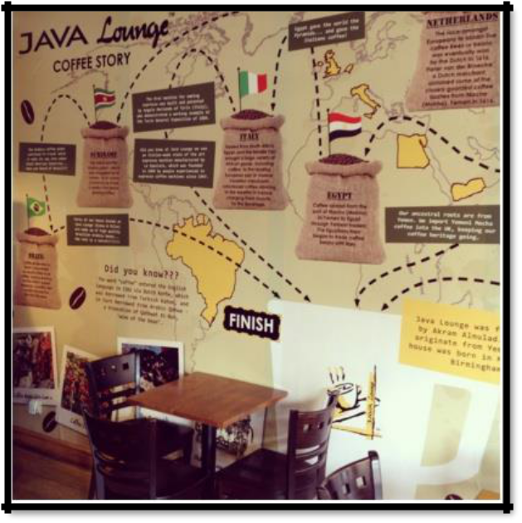

]

Informative ambience


Coffee offering

24

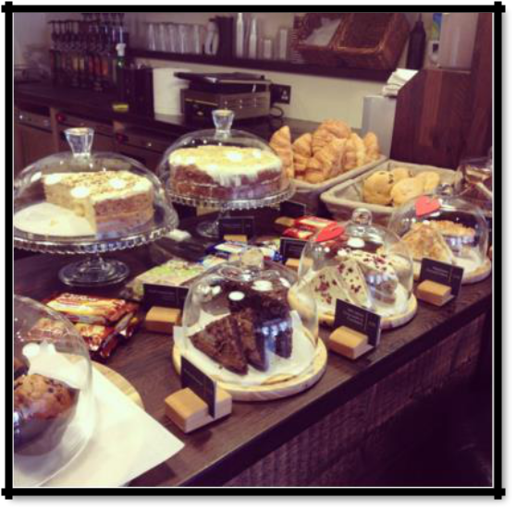

Beverage offering
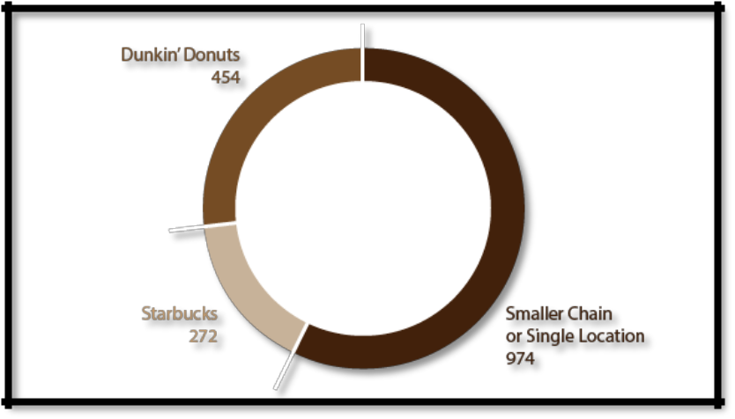

Breakdown of café types in UK market

25

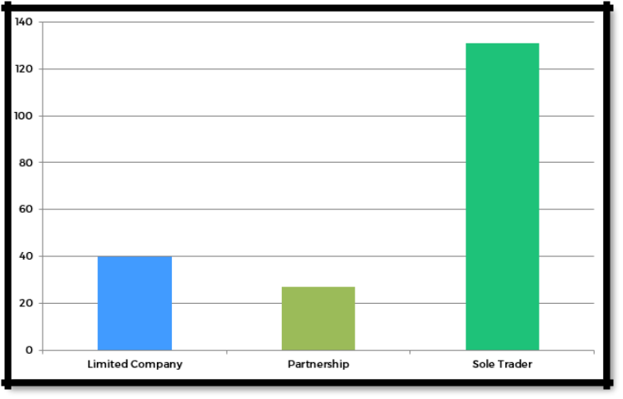

Small industry coffee shop revenue
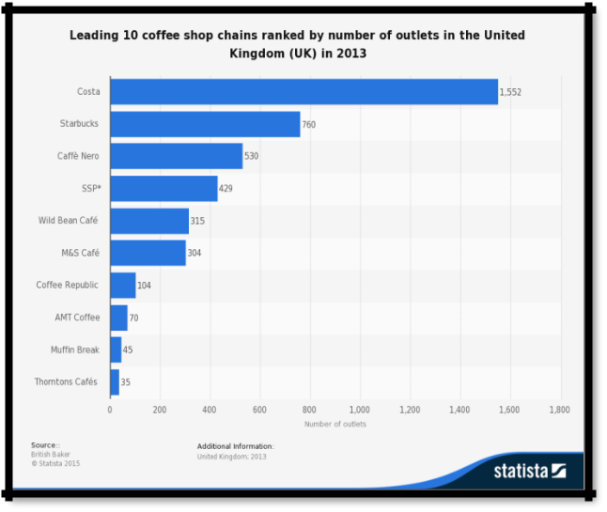

Leading coffee shops in UK

26

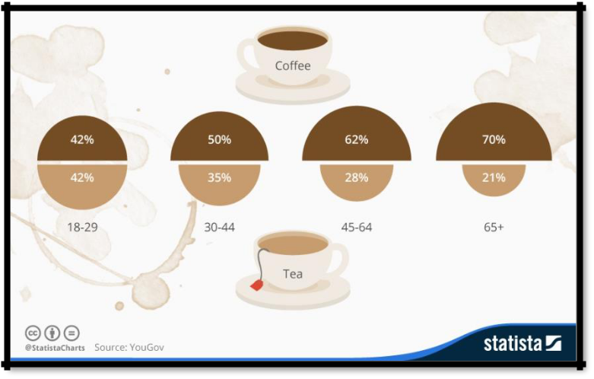

Percentage of coffee lovers in UK

27

